21.20: 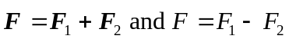 since they are acting in opposite directions at x = 0 so,

